Module – 1 Assignments
Design Principles & Patterns
Mandatory Hands-on :-
Exercise 2: Implementing the Factory Method Pattern
Scenario :
A leading digital payment company offers multiple payment options to its customers, including Credit Card Payments, UPI Payments, and Net Banking Payments. The application must create different payment processing objects based on the payment method selected by the customer. Hard-coding object creation throughout the application would increase code complexity and reduce maintainability. To overcome this challenge, the Factory Method Pattern is implemented to delegate object creation to a dedicated factory class, making the application more flexible and scalable.
Answers :
Introduction to Factory Method Pattern :
The Factory Method Pattern is a Creational Design Pattern that provides an interface for creating objects while allowing subclasses or factory classes to decide which specific object to instantiate. Instead of directly creating objects using the new keyword, object creation is centralized within a factory method. This approach promotes loose coupling between the client code and the concrete classes.
Need for Factory Method Pattern :
In software development, applications often need to create different types of objects based on user requirements or business rules. Direct object creation tightly couples the client code with concrete implementations, making future modifications difficult. The Factory Method Pattern solves this problem by encapsulating object creation logic inside a factory class, allowing new object types to be added with minimal code changes.
Key Features :
• Encapsulates object creation logic.
• Promotes loose coupling between classes.
• Simplifies maintenance and scalability.
• Supports the Open/Closed Principle.
• Makes code easier to extend and test.
Implementation Explanation :
In this implementation, an interface named IPaymentProcessor is created to define the common behaviour of all payment processors. Three concrete classes, namely CreditCardPayment, UPIPayment, and NetBankingPayment, implement this interface. A PaymentFactory class is responsible for creating the appropriate payment processor object based on the payment method provided by the user. The client interacts only with the factory and interface without knowing the exact class being instantiated.
Complexity Analysis :
The Factory Method Pattern efficiently creates objects by delegating the creation process to a dedicated factory class. Since object selection is based on simple conditional logic, the execution time remains constant for a limited number of payment types.
• Time Complexity : O(1)
• Space Complexity : O(1)
Real World Applications :
• Payment Gateway Systems
• Notification Services
• Document Generation Systems
• Logistics and Delivery Applications
• Vehicle Manufacturing Systems
Codes :-
File names :
Program.cs :
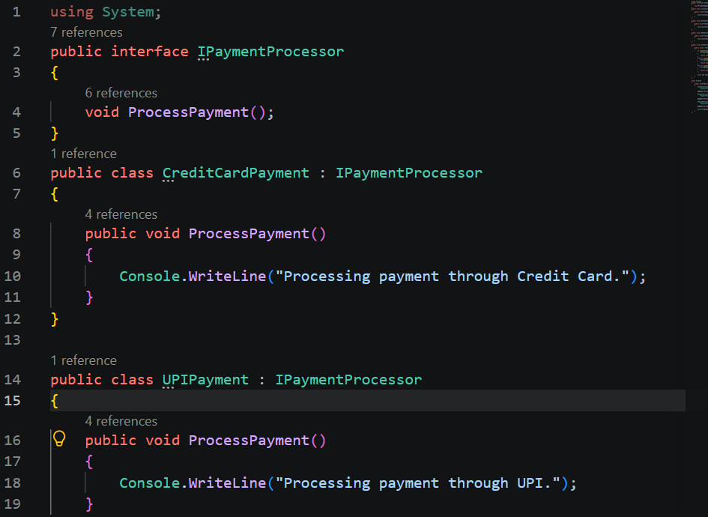
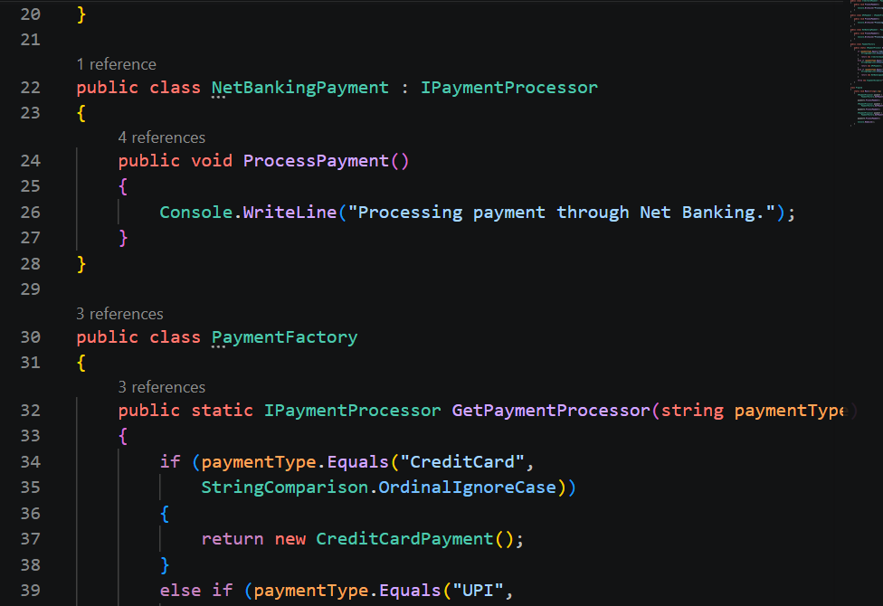
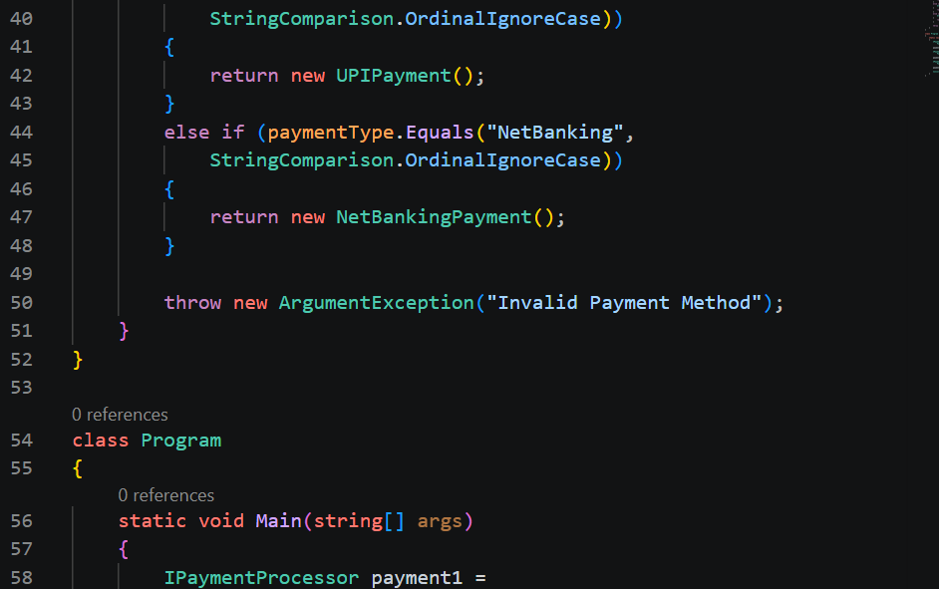
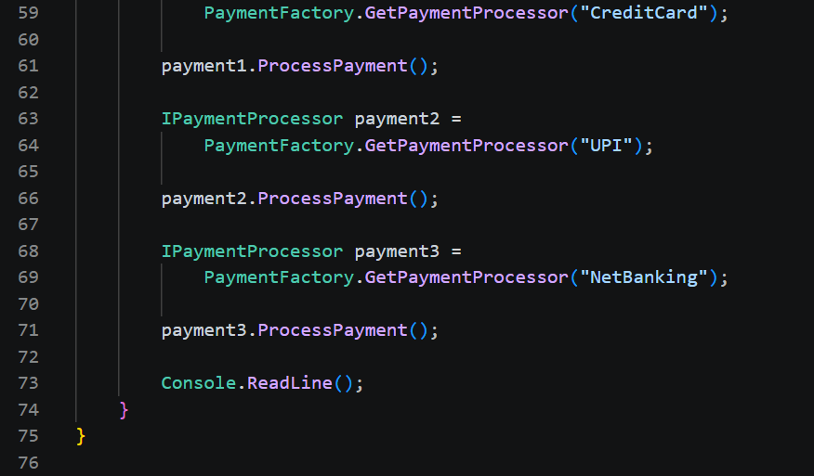
Output :-


Advantages of Factory Method Pattern :
• Reduces dependency on concrete classes.
• Improves code reusability.
• Makes the application scalable.
• Simplifies object creation management.
• Supports future enhancements without affecting existing code.
Which is Best?
The Factory Method Pattern is highly suitable for applications where object creation depends on user choices or runtime conditions. Instead of creating objects directly within the client code, the factory handles the instantiation process, resulting in cleaner, more maintainable, and extensible software architecture. This pattern is widely used in enterprise applications because it supports flexibility and simplifies future development efforts.
Conclusion:
The Factory Method Pattern was successfully implemented using a payment processing system scenario. The solution demonstrates how object creation can be centralized through a factory class while maintaining loose coupling between the client and concrete implementations. This approach improves maintainability, scalability, and adherence to software design principles, making it a valuable pattern in modern application development.

